Lab - Configuring IPv6 Addresses on Network Devices
Topology
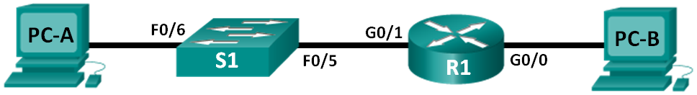
Addressing Table
Device | Interface | IPv6 Address | Prefix Length | Default Gateway
R1 | G0/0 | 2001:DB8:ACAD:A::1 | 64 | N/A
 | G0/1 | 2001:DB8:ACAD:1::1 | 64 | N/A
S1 | VLAN 1 | 2001:DB8:ACAD:1::B | 64 | N/A
PC-A | NIC | 2001:DB8:ACAD:1::3 | 64 | FE80::1
PC-B | NIC | 2001:DB8:ACAD:A::3 | 64 | FE80::1
Objectives
Part 1: Set Up Topology and Configure Basic Router and Switch Settings
Part 2: Configure IPv6 Addresses Manually
Part 3: Verify End-to-End Connectivity
Background / Scenario
Knowledge of the Internet Protocol version 6 (IPv6) multicast groups can be helpful when assigning IPv6 addresses manually. Understanding how the all-router multicast group is assigned and how to control address assignments for the Solicited Nodes multicast group can prevent IPv6 routing issues and help ensure best practices are implemented.
In this lab, you will configure hosts and device interfaces with IPv6 addresses and explore how the all-router multicast group is assigned to a router. You will use show commands to view IPv6 unicast and multicast addresses. You will also verify end-to-end connectivity using the ping and traceroute commands.
Note: The routers used with CCNA hands-on labs are Cisco 1941 ISRs with Cisco IOS Release 15.2(4)M3 (universalk9 image). The switches used are Cisco Catalyst 2960s with Cisco IOS Release 15.0(2) (lanbasek9 image). Other routers, switches and Cisco IOS versions can be used. Depending on the model and Cisco IOS version, the commands available and output produced might vary from what is shown in the labs. Refer to the Router Interface Summary table at the end of the lab for the correct interface identifiers.
Note: Make sure that the routers and switches have been erased and have no startup configurations. If you are unsure, contact your instructor.
Required Resources
- 1 Router (Cisco 1941 with Cisco IOS software, Release 15.2(4)M3 universal image or comparable)
- 1 Switch (Cisco 2960 with Cisco IOS Release 15.0(2) lanbasek9 image or comparable)
- 2 PCs (Windows 7 or 8 with terminal emulation program, such as Tera Term)
- Console cables to configure the Cisco IOS devices via the console ports
- Ethernet cables as shown in the topology
Note: The Gigabit Ethernet interfaces on Cisco 1941 routers are autosensing and an Ethernet straight-through cable may be used between the router and PC-B. If using another model Cisco router, it may be necessary to use an Ethernet crossover cable.
- Set Up Topology and Configure Basic Router and Switch Settings
  - Cable the network as shown in the topology.
  - Initialize and reload the router and switch.
  - Verify that the PC interfaces are configured to use the IPv6 protocol.
Verify that the IPv6 protocol is active on both PCs by ensuring that the Internet Protocol Version 6 (TCP/IPv6) check box is selected in the Local Area Connection Properties window.
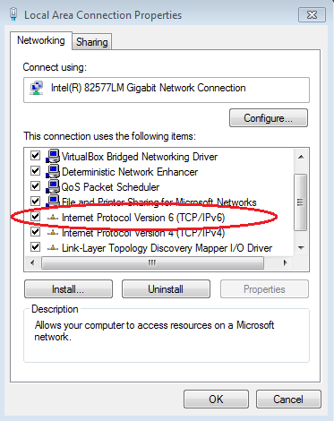
  - Configure the router.
    - Console into the router and enable privileged EXEC mode.
    - Assign the device name to the router.
    - Disable DNS lookup to prevent the router from attempting to translate incorrectly entered commands as though they were hostnames.
    - Assign class as the privileged EXEC encrypted password.
    - Assign cisco as the console password and enable login.
    - Assign cisco as the VTY password and enable login.
    - Encrypt the clear text passwords.
    - Create a banner that warns anyone accessing the device that unauthorized access is prohibited.
    - Save the running configuration to the startup configuration file.
  - Configure the switch.
    - Console into the switch and enable privileged EXEC mode.
    - Assign the device name to the switch.
    - Disable DNS lookup to prevent the router from attempting to translate incorrectly entered commands as though they were hostnames.
    - Assign class as the privileged EXEC encrypted password.
    - Assign cisco as the console password and enable login.
    - Assign cisco as the VTY password and enable login.
    - Encrypt the clear text passwords.
    - Create a banner that warns anyone accessing the device that unauthorized access is prohibited.
    - Save the running configuration to the startup configuration file.
- Configure IPv6 Addresses Manually
  - Assign the IPv6 addresses to Ethernet interfaces on R1.
    - Assign the IPv6 global unicast addresses, listed in the Addressing Table, to both Ethernet interfaces on R1.
R1(config)# interface g0/0
R1(config-if)# ipv6 address 2001:db8:acad:a::1/64
R1(config-if)# no shutdown
R1(config-if)# interface g0/1
R1(config-if)# ipv6 address 2001:db8:acad:1::1/64
R1(config-if)# no shutdown
R1(config-if)# end
R1#
    - Issue the show ipv6 interface brief command to verify that the correct IPv6 unicast address is assigned to each interface.
R1# show ipv6 interface brief
Em0/0 [administratively down/down]
unassigned
GigabitEthernet0/0 [up/up]
FE80::D68C:B5FF:FECE:A0C0
2001:DB8:ACAD:A::1
GigabitEthernet0/1 [up/up]
FE80::D68C:B5FF:FECE:A0C1
2001:DB8:ACAD:1::1
<output omitted>
    - Issue the show ipv6 interface g0/0 command. Notice that the interface is listing two Solicited Nodes multicast groups, because the IPv6 link-local (FE80) Interface ID was not manually configured to match the IPv6 unicast Interface ID.
Note: The link-local address displayed is based on EUI-64 addressing, which automatically uses the interface Media Access Control (MAC) address to create a 128-bit IPv6 link-local address.
R1# show ipv6 interface g0/0
GigabitEthernet0/0 is up, line protocol is up
IPv6 is enabled, link-local address is FE80::D68C:B5FF:FECE:A0C0
No Virtual link-local address(es):
Global unicast address(es):
2001:DB8:ACAD:A::1, subnet is 2001:DB8:ACAD:A::/64
Joined group address(es):
FF02::1
FF02::1:FF00:1
FF02::1:FFCE:A0C0
MTU is 1500 bytes
<output omitted>
    - To get the link-local address to match the unicast address on the interface, manually enter the link-local addresses on each of the Ethernet interfaces on R1.
R1# config t
Enter configuration commands, one per line. End with CNTL/Z.
R1(config)# interface g0/0
R1(config-if)# ipv6 address fe80::1 link-local
R1(config-if)# interface g0/1
R1(config-if)# ipv6 address fe80::1 link-local
R1(config-if)# end
R1#
Note: Each router interface belongs to a separate network. Packets with a link-local address never leave the local network; therefore, you can use the same link-local address on both interfaces.
    - Re-issue the show ipv6 interface g0/0 command. Notice that the link-local address has been changed to FE80::1 and that there is only one Solicited Nodes multicast group listed.
R1# show ipv6 interface g0/0
GigabitEthernet0/0 is up, line protocol is up
IPv6 is enabled, link-local address is FE80::1
No Virtual link-local address(es):
Global unicast address(es):
2001:DB8:ACAD:A::1, subnet is 2001:DB8:ACAD:A::/64
Joined group address(es):
FF02::1
FF02::1:FF00:1
MTU is 1500 bytes
<output omitted>
What multicast groups have been assigned to interface G0/0?
____________________________________________________________________________________
  - Enable IPv6 routing on R1.
    - On a PC-B command prompt, enter the ipconfig command to examine IPv6 address information assigned to the PC interface.
Has an IPv6 unicast address been assigned to the network interface card (NIC) on PC-B? _________
    - Enable IPv6 routing on R1 using the IPv6 unicast-routing command.
R1 # configure terminal
R1(config)# ipv6 unicast-routing
R1(config)# exit
R1#
*Dec 17 18:29:07.415: %SYS-5-CONFIG_I: Configured from console by console
    - Use the show ipv6 interface g0/0 command to see what multicast groups are assigned to interface G0/0. Notice that the all-router multicast group (FF02::2) now appears in the group list for interface G0/0.
Note: This will allow the PCs to obtain their IP address and default gateway information automatically using Stateless Address Autoconfiguration (SLAAC).
R1# show ipv6 interface g0/0
GigabitEthernet0/0 is up, line protocol is up
IPv6 is enabled, link-local address is FE80::1
No Virtual link-local address(es):
Global unicast address(es):
2001:DB8:ACAD:A::1, subnet is 2001:DB8:ACAD:A::/64 [EUI]
Joined group address(es):
FF02::1
FF02::2
FF02::1:FF00:1
MTU is 1500 bytes
<output omitted>
    - Now that R1 is part of the all-router multicast group, re-issue the ipconfig command on PC-B. Examine the IPv6 address information.
Why did PC-B receive the Global Routing Prefix and Subnet ID that you configured on R1?
____________________________________________________________________________________
____________________________________________________________________________________
  - Assign IPv6 addresses to the management interface (SVI) on S1.
    - Assign the IPv6 address listed in the Addressing Table to the management interface (VLAN 1) on S1. Also assign a link-local address for this interface. IPv6 command syntax is the same as on the router.
    - Verify that the IPv6 addresses are properly assigned to the management interface using the show ipv6 interface vlan1 command.
Note: The default 2960 Switch Database Manager (SDM) template does not support IPv6. It may be necessary to issue the command sdm prefer dual-ipv4-and-ipv6 default to enable IPv6 addressing before applying an IPv6 address to the VLAN 1 SVI.
  - Assign static IPv6 addresses to the PCs.
    - Open the Local Area Connection Properties window on PC-A. Select Internet Protocol Version 6 (TCP/IPv6) and click Properties.
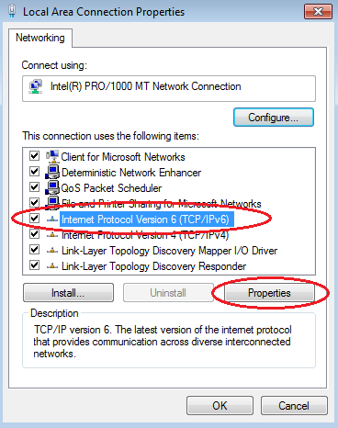
    - Click the Use the following IPv6 address radio button. Refer to the Addressing Table and enter the IPv6 address, Subnet prefix length, and Default gateway information. Click OK.
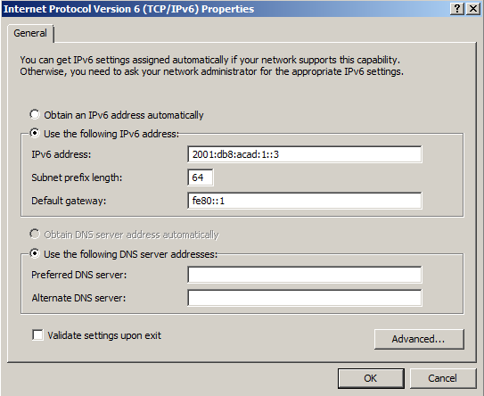
    - Click Close to close the Local Area Connection Properties window.
    - Repeat Steps 4a to c to enter the static IPv6 information on PC-B. For the correct IPv6 address information, refer to the Addressing Table.
    - Issue the ipconfig command from the command line on PC-B to verify the IPv6 address information.
- Verify End-to-End Connectivity
    - From PC-A, ping FE80::1. This is the link-local address assigned to G0/1 on R1.
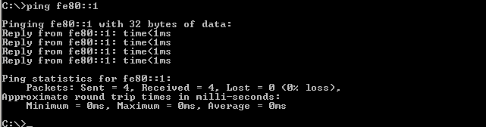
Note: You can also test connectivity by using the global unicast address, instead of the link-local address.
    - Ping the S1 management interface from PC-A.
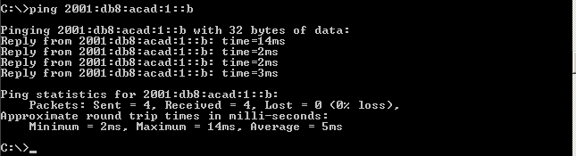
    - Use the tracert command on PC-A to verify that you have end-to-end connectivity to PC-B.
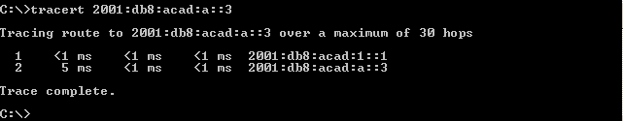
    - From PC-B, ping PC-A.
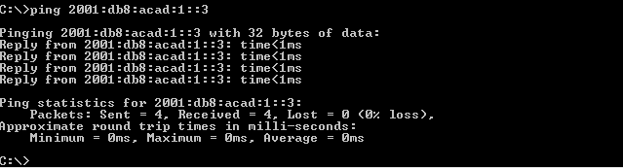
    - From PC-B, ping the link-local address for G0/0 on R1.
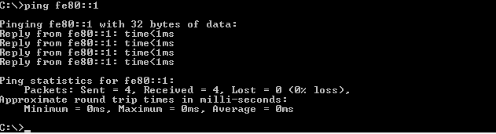
Note: If end-to-end connectivity is not established, troubleshoot your IPv6 address assignments to verify that you entered the addresses correctly on all devices.
Reflection
  - Why can the same link-local address, FE80::1, be assigned to both Ethernet interfaces on R1?
_______________________________________________________________________________________
_______________________________________________________________________________________
  - What is the Subnet ID of the IPv6 unicast address 2001:db8:acad::aaaa:1234/64?
_______________________________________________________________________________________
Router Interface Summary Table
Router Interface Summary
Router Model | Ethernet Interface #1 | Ethernet Interface #2 | Serial Interface #1 | Serial Interface #2
1800 | Fast Ethernet 0/0 (F0/0) | Fast Ethernet 0/1 (F0/1) | Serial 0/0/0 (S0/0/0) | Serial 0/0/1 (S0/0/1)
1900 | Gigabit Ethernet 0/0 (G0/0) | Gigabit Ethernet 0/1 (G0/1) | Serial 0/0/0 (S0/0/0) | Serial 0/0/1 (S0/0/1)
2801 | Fast Ethernet 0/0 (F0/0) | Fast Ethernet 0/1 (F0/1) | Serial 0/1/0 (S0/0/0) | Serial 0/1/1 (S0/0/1)
2811 | Fast Ethernet 0/0 (F0/0) | Fast Ethernet 0/1 (F0/1) | Serial 0/0/0 (S0/0/0) | Serial 0/0/1 (S0/0/1)
2900 | Gigabit Ethernet 0/0 (G0/0) | Gigabit Ethernet 0/1 (G0/1) | Serial 0/0/0 (S0/0/0) | Serial 0/0/1 (S0/0/1)
Note: To find out how the router is configured, look at the interfaces to identify the type of router and how many interfaces the router has. There is no way to effectively list all the combinations of configurations for each router class. This table includes identifiers for the possible combinations of Ethernet and Serial interfaces in the device. The table does not include any other type of interface, even though a specific router may contain one. An example of this might be an ISDN BRI interface. The string in parenthesis is the legal abbreviation that can be used in Cisco IOS commands to represent the interface.

